2023 Fall Trip To New England
Kevin L. Trevillyan, Potentate

I hope that you will be joining us on a trip to see the wonderful fall colors in New England September 24th to October 2nd, 2023. This is open to all Shriners, their families and friends. Reservations are due by February 8th.
We will fly into Boston Massachusetts and then take a chartered bus to Bar Harbor Maine where we will stay for two nights. Then we will travel to Sunday River Maine and stay for one night. Next it will be on to Burlington Vermont for a one night stay. After that we will travel to Brattleboro Vermont where we will stay for one night. We will then travel through Massachusetts and stay two nights in Hyannis Massachusetts. Our trip will end back in Boston Massachusetts and then fly back home.
We will have a private charter bus and tour guide. There will be side trips in the various cities that you will be able to participate in if you so choose. This will be a great trip and we really hope that you will consider being a part of the adventure. Please read through the information below and if you have any questions please contact me.

2023 New England Fall Tour:
Important Dates:
Sept 30th: Initial Non-Refundable Group Deposit of $500 due
February 8th: Traveler’s Non-Refundable $300 per person deposit + Any Trip Insurance would be due
Early March: Kevin & Michaela Touch Base on Traveler Numbers
July 11th: Traveler’s Final Payment Due

Cosmos Tours: Classic New England Escorted Tour
Tour Starts in Boston: September 24, 2023
Tour Ends in Boston: October 2, 2023

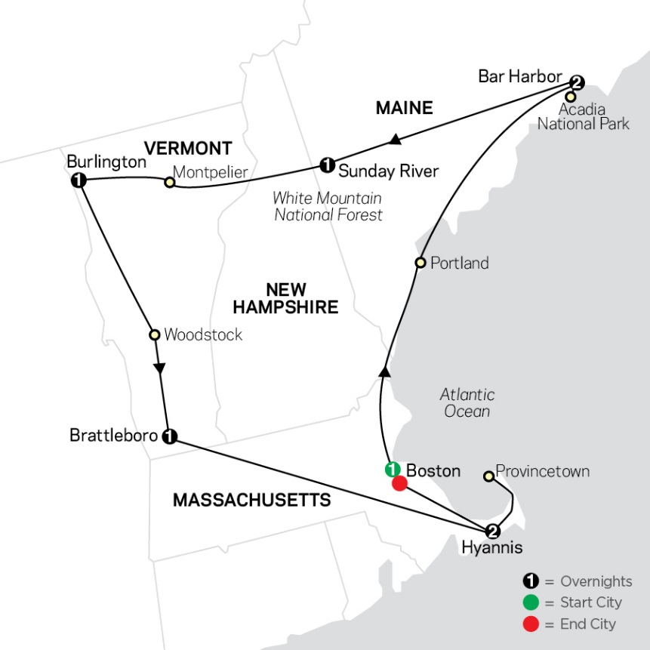

Please Note: Hotels COULD be different than those listed in the link. They will be of the same quality or better.
No discounts or price adjustments for alternative hotels.

Pricing Includes:
- 8 Night Tour as detailed in the link above
- 7 Included Breakfasts (Standard or Continental)
- Motorcoach Driver & Guide
- Driver & Guide Gratuities
- Creative Vacations Fee
- Taxes

Max Guests: 50
Max Rooms: 25

Pricing Details:
The following prices are based on TWO sharing a room and includes the TOUR and PRE-PAID GRATUITIES (Guide/Driver):
Final pricing will vary a bit, depending on our final head count.
50 passengers travel: $2190.00 per person, based on 2 sharing a room
40 passengers travel: $2725.00 per person, based on 2 sharing a room
30 passengers travel: $3620.00 per person, based on 2 sharing a room

IMPORTANT: If the group falls below 30 people this will be moved to a SHARED tour and pricing could adjust accordingly.

Only 10% of the guests can be Singles/Triple. Anything over that would need approval before we could confirm.
Single Passengers would add $805.00
Triple Rates would decrease approximately $200.00 per person

Airfare to/from Boston is NOT yet included.
If people have old credits, points or miles, they are welcome to use them for the airfare.
If people need assistance with airfare, we can certainly help with that when space opens (opens around early Nov 2022) we do have a $30 fee per person for every ticket issued.

Trip Insurance is approximately $249 per person and would be collected with the traveler’s deposit. This would be for the LAND package and will not cover the airfare.

Pre- or Post- Nights in Boston
Any travelers that might want to come in a day or two early or stay a day or two later, we can request space at the same hotels.
Pricing and availability are subject to availability, please reach out to Michaela for details.

Payment Info:
Initial Group NON-REFUNDABLE Deposit Due: $500 will secure the space for 50 people and 25 rooms

Traveler NON-REFUNDABLE Deposit of $300 per person + Any Trip Insurance would be due by February 8, 2023
Traveler Final Payment would be due in full by August 2, 2023

Please contact Michaela Moore with Creative Vacations to make your reservations. Here contact information is listed below.

Cancellation Details:
(Airfare, once purchased, is non-refundable and non-transferrable)

If you have any questions you can contact the Potentate: Kevin L. Trevillyan at kltrev@hotmail.com or (515) 240-8786.

You can also contact the travel agent:

Michaela Moore, VTA, CTA, LS
Senior Travel Advisor
Office: 515-963-4458
michaela@creativevacations.com
Business Hours: Mon-Fri 8:30am-5pm (CST)
Des Moines, Iowa | IST# 1079

